SIMATS ENGINEERING
SAVEETHA INSTITUTE OF MEDICAL AND TECHNICAL SCIENCES
CHENNAI – 602105
Department of Computer Science and Engineering

ASSESSMENT TOOL 2 – Open Data Analysis

Course Code: | DSA0502 | Course Title: | Query Processing for Data Science
CO Assessed: | CO4 | Assessment: | Tool 2– Open Data Analysis
Weightage: |  | Total Marks:
CO4 Statement: Explore datasets using analytical techniques such as grouping, correlation detection, joining datasets, and extracting meaningful insights.
Student Name: | SIDDARTH P | Reg. No.: | 192324264
Section / Batch: | 2023 | Date of Submission:
Faculty In-charge: | Dr. B.Shyamala Gowri | Project Mode: | Individual Submission

Code of Conduct
I_SIDDARTH P / 192324264_ (Name / Reg No) certify that this submission is my original work and that I have adhered to all guidelines specified for this assessment. I understand that any violation of academic integrity rules will result in disciplinary action.
Signature: SIDDARTH P

Question 8 – Tourism Data Analysis
Select any open tourism dataset containing tourist arrivals, destinations, hotel occupancy, travel expenditure, or visitor information. Explore and analyze the data using grouping, filtering, correlation, outlier detection, and time-series techniques. Present the findings through charts, maps, and interactive visualizations.

1. Dataset Selection
The selected open dataset is “Arrivals of tourists from abroad”, based on the UN Tourism Statistics Database and processed by Our World in Data (OWID). It measures the number of trips by visitors arriving from abroad and staying overnight. The OWID series covers 1995–2024 and is openly reusable under CC BY with attribution.
For the main comparison, 2024 destination values are used. International visitor spending for 2024 is added from the corresponding OWID tourism spending series to examine the relationship between arrivals and tourism receipts.

2. Data Importing and Basic Exploration
import pandas as pd
df = pd.read_csv("international-tourist-trips.csv")
print(df.head())
print(df.info())
print(df.isnull().sum())
print(df.describe())

The selected extract contains destination, country code, year and international tourist arrivals. The original open dataset provides annual observations for multiple years, which allows a recent time-series comparison.

Country | Arrivals (M) | Spending (US$ B)
United States | 72.39 | 251.65
Spain | 93.76 | 106.66
Italy | 57.73 | 61.43
Turkey | 50.45 | 78.21
France | 48.40 | 85.94
Mexico | 45.04 | 36.24
United Kingdom | 38.23 | 84.55
Germany | 37.42 | 40.13
Japan | 36.87 | 58.63
Saudi Arabia | 29.73 | 46.34

3. Filtering and Sorting
Destinations with at least 20 million international arrivals are filtered and sorted from highest to lowest.
high_arrivals = tourism[
(tourism["Year"] == 2024) &
(tourism["Arrivals_M"] >= 20)
].sort_values(
"Arrivals_M",
ascending=False
)
print(high_arrivals)

Country | Arrivals (M)
Spain | 93.76
United States | 72.39
Italy | 57.73
Turkey | 50.45
France | 48.40
Mexico | 45.04
United Kingdom | 38.23
Germany | 37.42
Japan | 36.87
Saudi Arabia | 29.73
Portugal | 28.97
Greece | 27.84
Austria | 26.21

4. Grouping and Comparison
For a simple comparison, the selected destinations are grouped by broad geographic region. These groups are created only for this analysis.
Group | Countries | Average Arrivals (M)
Europe | Spain, Italy, France, UK, Germany, Portugal, Greece, Austria, Poland, Netherlands, Croatia, Denmark | 35.32
North America | United States, Mexico, Canada | 45.78
Asia | Japan, South Korea, Indonesia, Singapore, India, Malaysia | 16.63
Middle East | Turkey, Saudi Arabia | 40.09

5. Correlation Analysis
Pearson correlation is used to compare tourist arrivals, tourism spending and spending per arrival.
corr = tourism[
["Arrivals_M",
"Spending_B",
"Spending_per_Arrival_USD"]
].corr()
print(corr.round(2))

Variable | Arrivals_M | Spending_B | Spending_per_Arrival_USD
Arrivals_M | 1.00 | 0.74 | -0.01
Spending_B | 0.74 | 1.00 | 0.51
Spending_per_Arrival_USD | -0.01 | 0.51 | 1.00

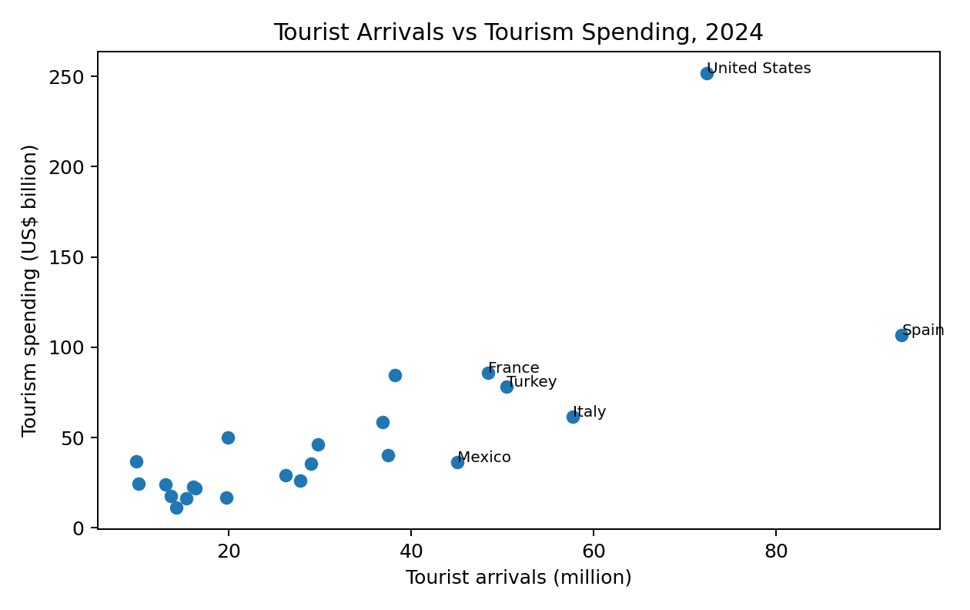
The correlation between tourist arrivals and tourism spending is approximately 0.74. This indicates a strong positive association in the selected-country sample, although correlation does not by itself establish causation.

6. Outlier Detection
The Interquartile Range (IQR) method is applied to 2024 tourist arrivals. Values above Q3 + 1.5×IQR are treated as potential high-side outliers.

q1 = tourism["Arrivals_M"].quantile(0.25)
q3 = tourism["Arrivals_M"].quantile(0.75)
iqr = q3 - q1
upper = q3 + 1.5 * iqr
outliers = tourism[
tourism["Arrivals_M"] > upper
]
print(outliers)

Country | Arrivals (M)
Spain | 93.76

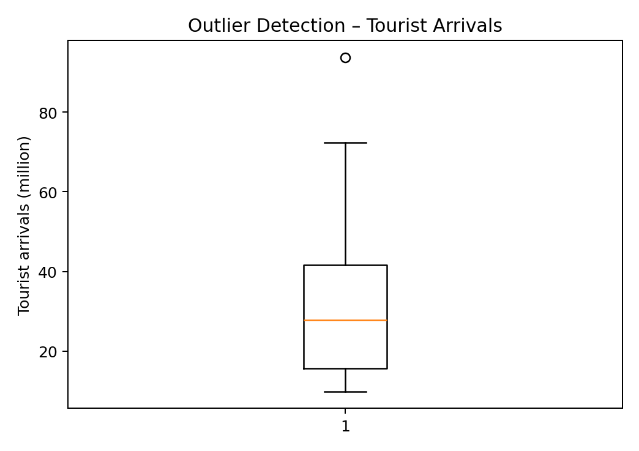
The calculated upper IQR boundary is about 80.55 million arrivals. Spain is the high-side outlier in this selected comparison, with approximately 93.76 million arrivals.

7. Time-Series Analysis
A recent 2022–2024 comparison is shown for Spain, the United States and Hungary. This demonstrates time-based analysis without adding unnecessary long-term modelling.

trend = tourism[
tourism["Country"].isin(
["Spain", "United States", "Hungary"]
)
]
trend = trend[
trend["Year"].between(2022, 2024)
]
print(trend)

Year | Spain | United States | Hungary
2022.00 | 71.66 | 50.77 | 12.65
2023.00 | 85.17 | 66.35 | 12.93
2024.00 | 93.76 | 72.39 | 13.15

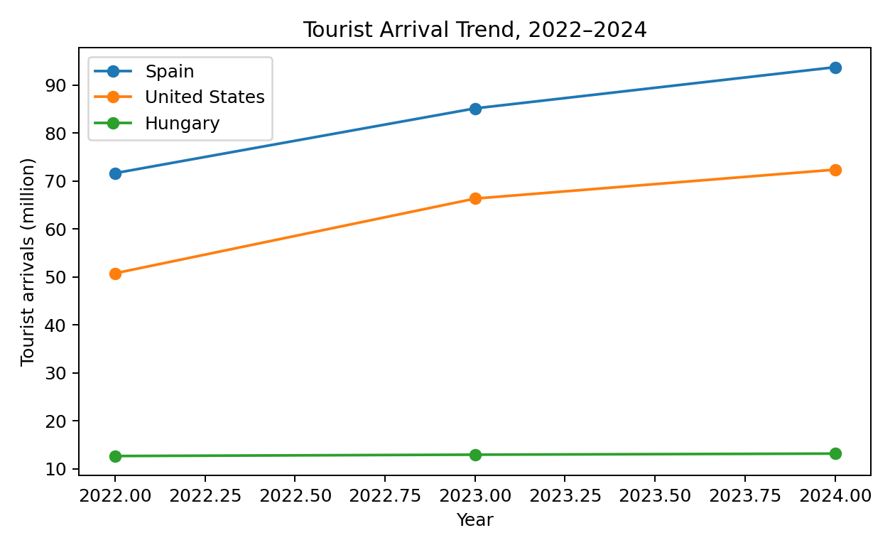
Spain increased from 71.66 million arrivals in 2022 to about 93.76 million in 2024. The United States increased from 50.77 million to about 72.39 million, while Hungary changed more gradually from 12.65 million to about 13.16 million.

8. Charts and Geographical Visualization
The following charts present the main destination comparison and the geographical distribution of the selected destinations.
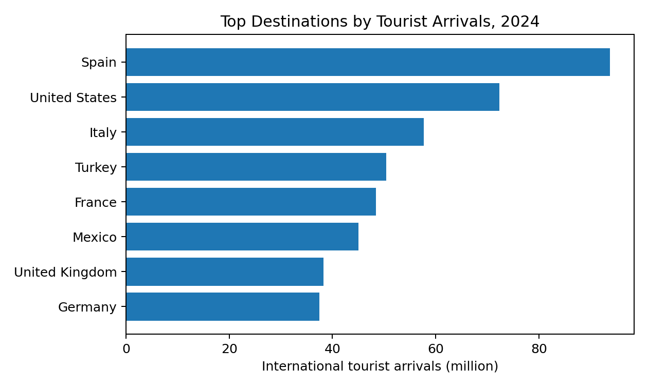
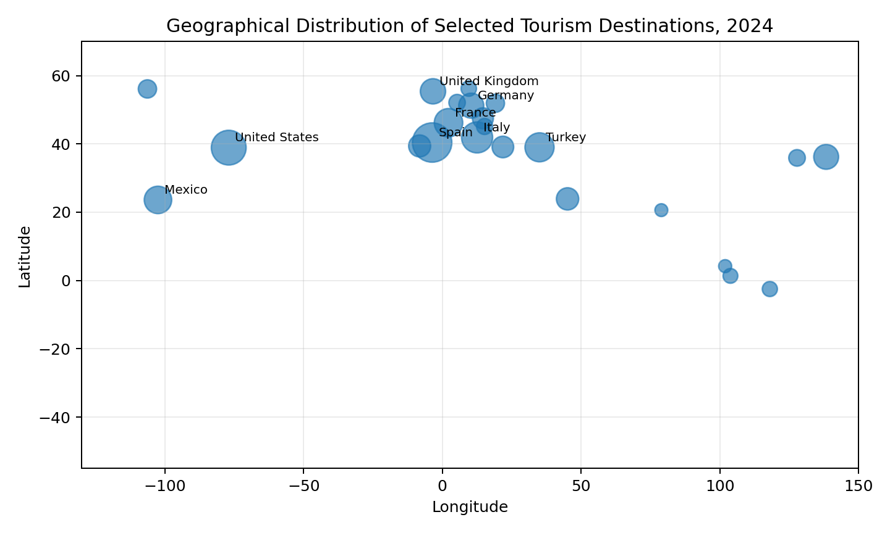
Marker size in the geographical visualization represents the relative number of tourist arrivals. The plot is intended as a compact destination map for comparison.

9. Interactive Visualization
A Plotly dashboard was created with four interactive views: 2024 arrivals, arrivals versus spending, the 2022–2024 trend and a geographical destination view. Hovering over points displays country-level values.
import plotly.express as px
fig = px.scatter_geo(
tourism,
lat="Latitude",
lon="Longitude",
size="Arrivals_M",
hover_name="Country",
color="Arrivals_M",
projection="natural earth",
title="International Tourism Destinations"
)
fig.show()
The complete interactive dashboard is supplied as a separate HTML file and can be opened directly in a browser.

10. Findings and Conclusion
- Spain records the highest tourist-arrival value in the selected 2024 comparison, at about 93.76 million.
- The United States records the highest tourism spending in the selected 2024 comparison, at about US$251.65 billion.
- Tourist arrivals and tourism spending have a positive correlation of about 0.74 in the selected sample.
- Spain is the main high-side outlier under the IQR rule.
- The 2022–2024 trend shows strong recent growth for Spain and the United States, while Hungary changes more gradually.
Conclusion: The open tourism data supports filtering, grouping, correlation analysis, outlier detection and time-series analysis. The charts and geographical view make destination differences clear, while the Plotly dashboard provides an interactive way to explore the same results.

Source and Data Note
Primary source: Our World in Data, “Arrivals of tourists from abroad”, based on the UN Tourism Statistics Database. The indicator counts arrivals/trips rather than unique people; one person can generate multiple arrivals. The corresponding tourism spending series is also from Our World in Data and is based on UN Tourism. The assessment specifically asks for an open tourism dataset and the listed analytical techniques. citeturn1file0L51-L54
Data access: Our World in Data provides the tourism dataset as downloadable CSV data and states that its work is openly accessible under CC BY with attribution.

FULL Working Code

import pandas as pd
# Import
tourism = pd.read_csv("international-tourist-trips.csv")
spending = pd.read_csv("tourism-spending.csv")
# Filter 2024
tourism = tourism[tourism["Year"] == 2024]
# Merge
tourism = tourism.merge(
spending[["Entity", "Year", "Spending_USD"]],
on=["Entity", "Year"],
how="left"
)
# Derived measures
tourism["Arrivals_M"] = (
tourism["Arrivals of tourists from abroad"] / 1e6
)
tourism["Spending_B"] = (
tourism["Spending_USD"] / 1e9
)
tourism["Spending_per_Arrival_USD"] = (
tourism["Spending_USD"] /
tourism["Arrivals of tourists from abroad"]
)
# Filtering and sorting
high = tourism[
tourism["Arrivals_M"] >= 20
].sort_values(
"Arrivals_M",
ascending=False
)
# Correlation
print(
tourism[
["Arrivals_M", "Spending_B",
"Spending_per_Arrival_USD"]
].corr()
)
# IQR outliers
q1 = tourism["Arrivals_M"].quantile(0.25)
q3 = tourism["Arrivals_M"].quantile(0.75)
iqr = q3 - q1
outliers = tourism[
tourism["Arrivals_M"] >
q3 + 1.5 * iqr
]
print(outliers)
# Time series
trend = pd.read_csv(
"international-tourist-trips.csv"
)
trend = trend[
trend["Entity"].isin(
["Spain", "United States", "Hungary"]
)
]
trend = trend[
trend["Year"].between(2022, 2024)
]
print(trend)

